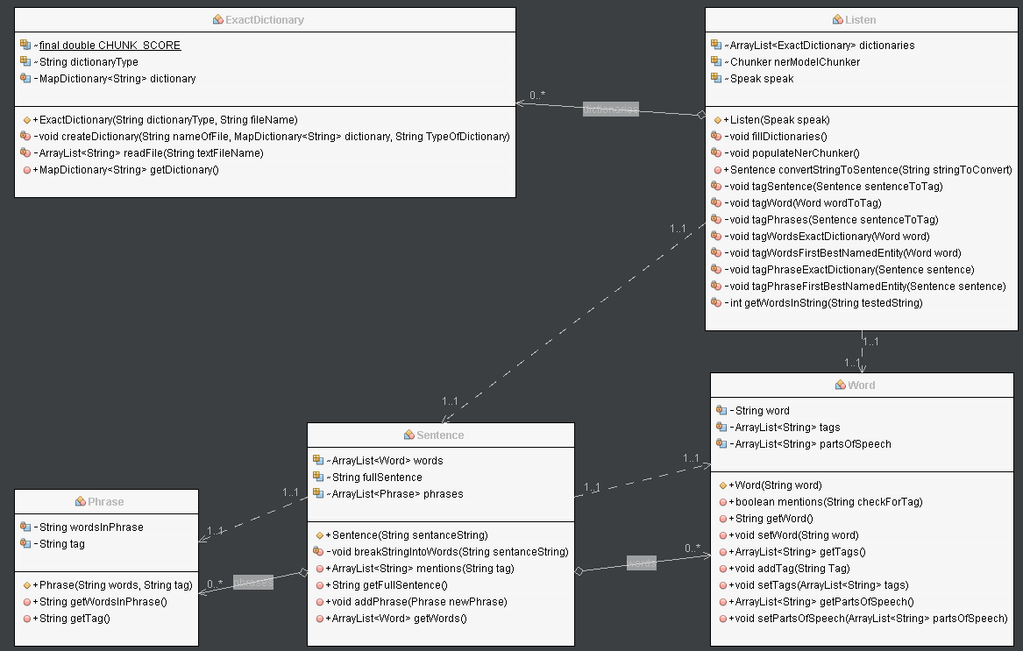

# Exact Dictionary

The Exact Dictionary class is one of the base ways to examine and determine the meaning of words in the Ling Pipe NLP Processor. It compares words against a set of words and only if the word(s) match 100% it will report a match.

## Constants

Chunk Score – A double variable that is required by the exact dictionary chunker, the only valid entry is 1.00.

## Class Variables

Dictionary Type – A String for the name for the dictionary. This variable is what tag will be for the word(s) that are matched to the dictionary

Dictionary – The variable type that is created by this class and what is used by the chunker to perform the comparison operations

## Constructors

### Primary

The only constructor that this class contains, it requires the class variable Map Dictionary and the file name that contains a [Enter] delimited list of words that will be part of the dictionary. In the file each line contains one match, a match can contain 1 to infinite words. The constructor initializes the Dictionary variable, sets the Dictionary Type variable and calls the create dictionary method

# Private Methods

## Create Dictionary

t

## Read File

t

# Public Methods

## Get Dictionary

t

# Integration Information

## Listen Class

t

# Listen

## Class Variables

Dictionaries

Ner Model Chunker

Speak

## Constructors

### Primary

The only

## Private Methods

### Fill Dictionaries

t

### Populate net Chunker

t

### Tag Sentence

T

### Tag Word

### Tag Phrases

### Tag Words Exact Dictionary

### Tag Phrase Exact Dictionary

### Tag Phrase First Best Named Entity

### Get Words in String

## Public Methods

### Convert String to Sentence

## Integration Information

### Sentence

# Word

## Class Variables

Word

Tags

Parts Of Speech

## Constructors

### Primary

## Public Methods

### Mentions

### Get word

### Set word

### Get tags

### Add tag

### Set tags

### Get parts of speech

### Set parts of speech

## Integration Information

Sentence

# Phrase

## Class Variables

Words in Phrase

Tag

## Constructors

### Primary

## Public Methods

### Get words in phrase

### Get tag

## Integration Information

### Sentence

# Sentence

## Class Variables

Words

Full Sentence

phrases

## Constructors

### Primary

## Private Methods

### Break String into Words

## Public Methods

### Mentions

### Get Full Sentence

### Add Phrase

### Get words